**Sudoku Assistant**

Can be used to either solve Sudoku puzzles or to assist in solving one.

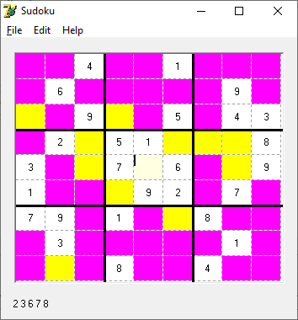

To initialize the board, click on each *known* square and enter its number (1..9). You may tab from column to column.

Hovering over a square will display the (possible/actual) values in the lower left-hand corner).

Squares with a known value are shown in white. The value of the square is also shown in the lower left -hand corner.

Squares with no possible value are shown in red.

Squares with only one possible value are shown in green. The one possible value is shown in the lower left-hand corner.

Squares with only two possible values are shown in yellow. The two possible values are shown in the lower left-hand corner.

Squares with more than two possible values are shown in Fuchsia. The possible values are shown in the lower left-hand corner.

The *File/Revert* menu will reload from the *Save* file which is named “SUDOKU.TXT” by default.

At any time, the *“File/Solve It”* menu item can be used to solve the puzzle.